**Front-End UI/UX Mini Project**

**Project report**

**Photo gallery**

• Submitted By:

o Team Members- Aanya Dayanand ,Sharilyn Fiona Dsilva, Y.Ghnana Maheedhar

o Register Number- 2460302 ,2460449 , 2460475

o College-E-mail id-

• Course: UI/UX Developer

• Instructor Name: Dhiraj alate

• Institution: Christ University

• Date of Submission: 26/09/2025

• Abstract:

The Photo Gallery project is a responsive web-based application designed to showcase a collection of images in an organized and visually appealing manner. Using HTML for structure, CSS for styling, and JavaScript/jQuery for interactivity, the gallery allows users to view images in a grid layout and enlarge them in a modal window with smooth navigation. The integration of animations, hover effects, and transitions creates an engaging and modern user experience, making the gallery suitable for portfolios, event displays, and personal collections.

Beyond its visual appeal, the project emphasizes **user-friendly navigation and responsiveness**. The gallery adapts seamlessly to different screen sizes using Bootstrap’s grid system, ensuring accessibility on mobile, tablet, and desktop devices. Modal functionality, combined with keyboard navigation and animation effects, enhances usability. This project not only demonstrates core front-end development skills but also lays the foundation for future enhancements such as category filtering, database integration, and dynamic content loading.

• Objectives :

The Photo Gallery project is developed to provide a modern and responsive platform for showcasing images interactively. It focuses on enhancing user engagement through smooth design, seamless navigation, and responsive features that work across all devices. The project also aims to demonstrate the integration of **HTML, CSS, JavaScript, and jQuery** in building a practical front-end mini project.

**Objectives:**

1. **Create a responsive gallery layout**  
   To ensure images adapt gracefully across devices such as desktops, tablets, and smartphones using Bootstrap’s grid system.
2. **Implement an interactive modal viewer**  
   To allow users to click on thumbnails and view larger versions of images in a pop-up modal.
3. **Enable smooth image navigation**  
   To provide next and previous buttons inside the modal for browsing images conveniently.
4. **Support keyboard navigation**  
   To enhance accessibility by allowing navigation using left and right arrow keys.
5. **Apply engaging animations**  
   To improve the visual appeal by adding fade-in effects and hover transitions on images.
6. **Improve user experience with hover effects**  
   To give feedback on interaction by zooming images slightly and adding shadows when hovered.
7. **Ensure aesthetic design with overlays**  
   To enhance the hero section using background images, overlays, and styled titles for a professional look.
8. **Provide clean and organized code**  
   To structure HTML, CSS, and JavaScript logically, making the project easy to read and maintain.

• Scope of the Project :

The scope of the Photo Gallery project lies in creating a fully responsive and interactive platform where users can view and navigate through images effortlessly. It is designed to serve a wide variety of purposes, such as personal portfolios, event showcases, photography collections, and business websites that require a visually appealing image display. With the use of Bootstrap, the gallery ensures adaptability across all screen sizes, from desktops to mobile devices, making it accessible to a broad audience. The inclusion of animations, hover effects, and modal navigation further improves user interaction and engagement.

In addition, the project demonstrates core concepts of front-end development using HTML, CSS, JavaScript, and jQuery, making it an excellent mini-project for students and beginners. While the current version focuses on static image display, the system can be scaled to include advanced features like category filtering, search functionality, dynamic loading from a database, and integration with backend technologies. Thus, the scope is not only limited to showcasing static images but also extends towards becoming a complete gallery solution adaptable to various real-world applications.

• Tools & Technologies Used :

| **Tool / Technology** | **Purpose** |
| --- | --- |
| **HTML5** | Structures the form elements semantically and ensures accessibility. |
| **CSS3** | Styles the form, error messages, layout, and improves visual appeal. |
| **JavaScript** | Handles validation logic, event handling, and form submission control. |
| **jQuery** | Simplifies DOM manipulation, event handling, and error message display. |
| **Bootstrap 5** | Provides a responsive layout, prebuilt components, and consistent styling. |
| **Web Browser** | Used for testing, debugging, and displaying the form during development. |

• HTML Structure Overview :

The HTML structure of the Photo Gallery project is organized into well-defined sections to ensure clarity, readability, and ease of maintenance. At the top, the document follows standard HTML5 conventions with the <!DOCTYPE html> declaration and includes essential meta tags for character encoding and responsiveness. External resources such as **Bootstrap CSS**, a custom stylesheet (style.css), and **jQuery** are linked within the <head> and at the bottom of the <body> for proper functionality.

The **Hero Section** is placed at the beginning of the <body> to provide an introductory visual area with a background image, an overlay for contrast, and a centered heading and subheading. This section sets the theme and title of the project (“Photo Gallery”) and gives users a clear entry point.

The **Gallery Section** forms the core of the project. It is built using Bootstrap’s grid system (container-fluid, row, and multiple col classes). Each image is inserted inside a <div> column with the class .gallery-img applied for styling and interactivity. This modular structure allows easy scalability — more images can be added without breaking the layout.

The **Modal Section** is defined at the bottom of the HTML. It contains a Bootstrap modal component customized to display images in a larger view when clicked. The modal includes navigation buttons (prevBtn and nextBtn) on either side of the image, as well as keyboard navigation support implemented via JavaScript/jQuery.

• CSS Styling Strategy :

The CSS for the Photo Gallery project is designed to balance **aesthetic appeal, responsiveness, and user interactivity**. The styling begins with setting a modern background using a linear gradient and applying the Poppins font for a clean and professional look. A consistent color palette is maintained throughout the project, combining dark overlays, neutral text, and vibrant hover effects to enhance readability and engagement.

The **Hero Section** is styled with a background image that covers the entire section and is overlaid with a semi-transparent black layer. This overlay increases contrast, ensuring that the white heading and subheading remain clearly visible regardless of the background image. Positioning is handled with relative and absolute properties so that the text stays centered both vertically and horizontally.

The **Gallery Images** form the most interactive part of the design. Each image is styled with rounded corners (border-radius), hover zoom effects (transform: scale), and box shadows to create a depth effect. To ensure consistency across different screen sizes, fixed height and object-fit: cover are applied so that all thumbnails appear uniform. Additionally, a **fade-in animation** with staggered delays is applied to each image (nth-child selectors), making the gallery load gracefully instead of appearing abruptly.

For the **Modal Section**, CSS removes the default Bootstrap background and replaces it with a semi-transparent dark overlay, allowing the enlarged image to stand out. The modal image itself is styled with rounded corners and a maximum height constraint to prevent overflow on smaller screens. Navigation buttons (.nav-btn) are styled as circular, semi-transparent elements with hover effects that increase opacity. Their position is fixed to the vertical center on the left and right sides of the modal, ensuring ease of navigation.

• **JavaScript Overview :**

The JavaScript in the Photo Gallery project, enhanced with **jQuery**, is responsible for adding interactivity and dynamic behavior to the otherwise static HTML and CSS layout. It manages how users interact with the gallery, from opening images in a modal to navigating between them using buttons or keyboard shortcuts. The code is structured to be simple, efficient, and reusable.

The script begins by storing all gallery images in a jQuery selector ($(".gallery-img")) and initializing a variable currentIndex to keep track of which image is currently being viewed. This index updates every time a user interacts with the gallery, ensuring the modal always shows the correct image.

The **image click event** is one of the core features. When a user clicks on a thumbnail, the script identifies its index in the gallery and then calls the updateModalImage() function. This function retrieves the src attribute of the selected image and sets it as the source of the modal image (#modalImage), effectively displaying the clicked image in a larger view. At the same time, the modal is triggered to appear ($("#imageModal").modal("show")).

Navigation inside the modal is handled through **Next** and **Previous buttons**. When the "Next" button is clicked, the currentIndex increases by one, and if it reaches the end, it loops back to the first image using the modulo operator. Similarly, when the "Previous" button is clicked, the index decreases, looping to the last image if necessary. In both cases, the updateModalImage() function refreshes the modal with the new image source.

In addition to button navigation, the script also implements **keyboard navigation**. By listening to the keydown event, the script detects whether the modal is currently visible (hasClass("show")). If it is, pressing the **Right Arrow** triggers the "Next" action, while the **Left Arrow** triggers the "Previous" action. This provides a more accessible and intuitive way to browse through the gallery, especially for desktop users.

• Key Features :

1. **Responsive Grid Layout**  
   The gallery is built using Bootstrap’s grid system, ensuring that images automatically adjust to different screen sizes for seamless viewing on desktops, tablets, and mobiles.
2. **Hero Section with Overlay**  
   A visually striking hero section introduces the gallery with a background image, semi-transparent overlay, and centered text, giving the project a professional look.
3. **Interactive Image Thumbnails**  
   All images are displayed as thumbnails with rounded corners, hover effects, and consistent dimensions, creating a neat and organized gallery layout.
4. **Image Modal Viewer**  
   Clicking a thumbnail opens a modal window with a larger view of the image, enhancing the user’s experience by allowing them to focus on details.
5. **Next and Previous Navigation**  
   The modal includes navigation buttons on either side, allowing users to move through the gallery without closing the modal repeatedly.
6. **Keyboard Navigation Support**  
   Users can navigate between images using the left and right arrow keys, providing a convenient and accessible way to interact with the gallery.
7. **Hover Zoom and Shadow Effects**  
   Each thumbnail reacts to user interaction with smooth zoom-in and shadow effects, making the gallery dynamic and engaging.
8. **Fade-in Animation for Images**  
   Images appear with staggered fade-in animations when the page loads, giving the gallery a polished and modern feel.
9. **Lightweight and Reusable Design**  
   The project uses clean, modular HTML, CSS, and JavaScript, making it easy to reuse or expand for different portfolios, events, or business needs.
10. **Cross-Browser Compatibility**  
    By using standard HTML5, CSS3, and jQuery features, the gallery functions consistently across all major browsers, ensuring wider accessibility.

• Challenges Faced & Solutions :

**1.Maintaining responsiveness across devices**  
Initially, the gallery layout broke on smaller screens.  
**Solution:** Implemented Bootstrap’s grid system with col-sm, col-md, and col-lg classes for flexible scaling.

**2.Modal image not updating correctly**  
At first, the same image appeared even after clicking different thumbnails.  
**Solution:** Used currentIndex to track the clicked image and updated the modal source dynamically through updateModalImage().

**3.Smooth animations without performance issues**  
Animations caused lag when loading multiple images.  
**Solution:** Applied lightweight CSS keyframe animations with staggered delays for a polished but efficient effect.

**4.Navigation looping at image boundaries**  
Navigating forward from the last image or backward from the first caused errors.  
**Solution:** Used modulo arithmetic to loop indices and prevent crashes when reaching gallery ends.

**5.Keyboard navigation not functioning**  
Arrow key events didn’t respond when the modal was open.  
**Solution:** Added a keydown listener that only activates when the modal has the show class.

**6.Consistent image sizing**  
Different aspect ratios made thumbnails look uneven.  
**Solution:** Applied fixed height with object-fit: cover to ensure all thumbnails remain uniform.

• Outcome :

The outcome of the Photo Gallery project is a fully functional, responsive, and interactive web application that provides users with a modern way to browse and view images. The gallery successfully combines aesthetics with functionality, offering hover effects, animations, and modal navigation that make the experience engaging. With features like responsive layouts, keyboard shortcuts, and smooth transitions, the project demonstrates practical implementation of HTML, CSS, JavaScript, and jQuery. It also showcases the effectiveness of Bootstrap for building adaptable grid-based designs. The project serves as a complete front-end solution for anyone looking to display collections of photos in a professional and user-friendly format.

• Future Enhancements :

Looking forward, the project has strong potential for feature enhancement and scalability. Future improvements could include adding **image captions and descriptions**, implementing **category filters** for sorting images, and integrating a **search functionality** for easy navigation. Advanced features such as **swipe gestures for mobile devices**, **lazy loading of images** for performance optimization, and **database integration** for dynamic content can transform the project from a simple static gallery into a robust photo management system. These enhancements would not only improve usability but also expand the project’s applications for professional portfolios, event organizers, businesses, and online photo-sharing platforms.

• Sample Code :

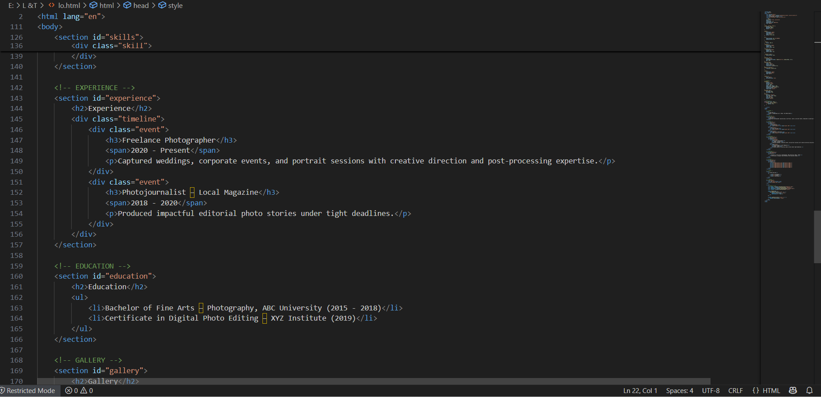

HTML structure

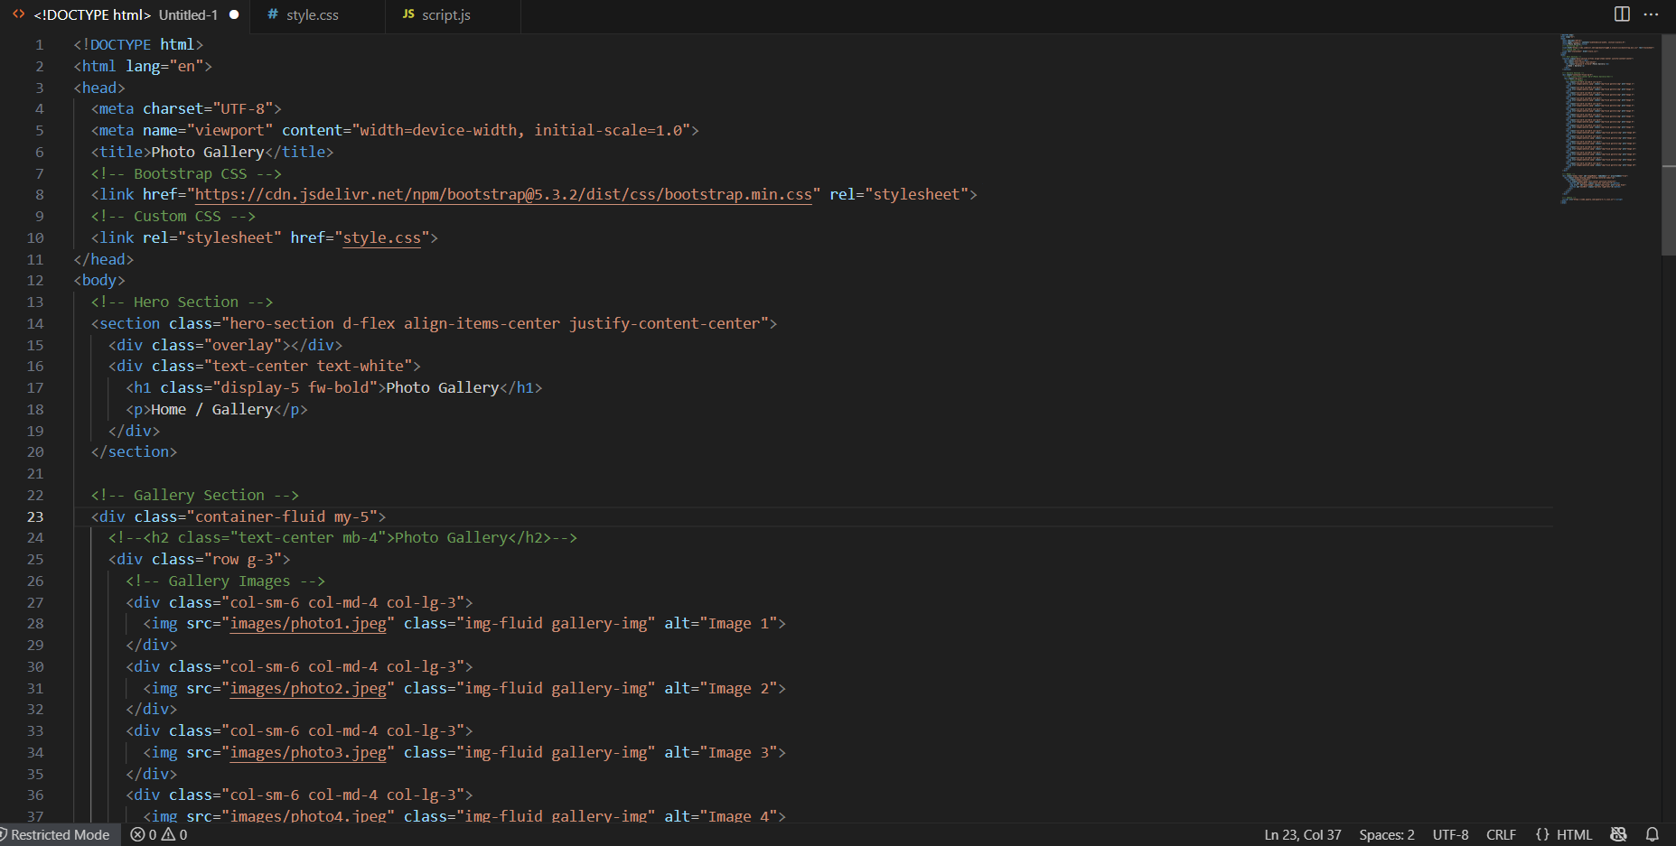

CSS structure

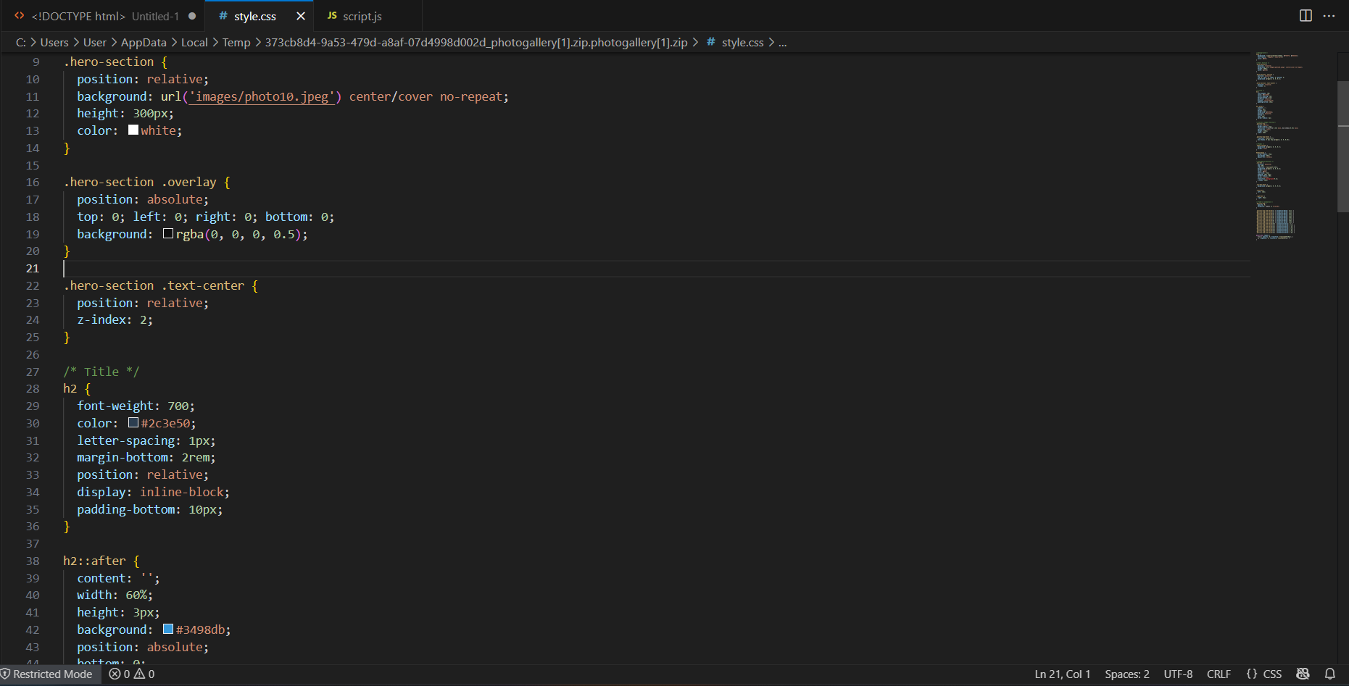

• Java script/Jquery code :

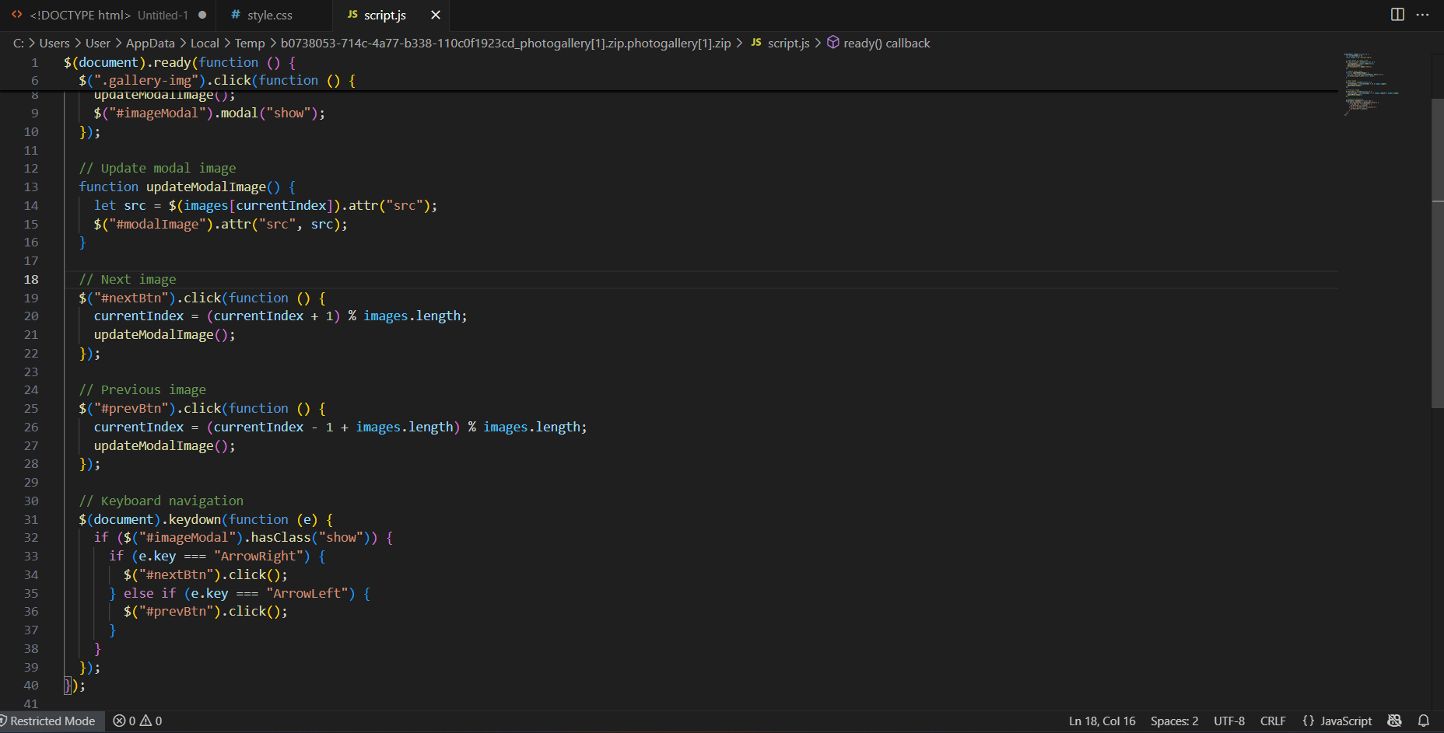

• Screenshot of output :

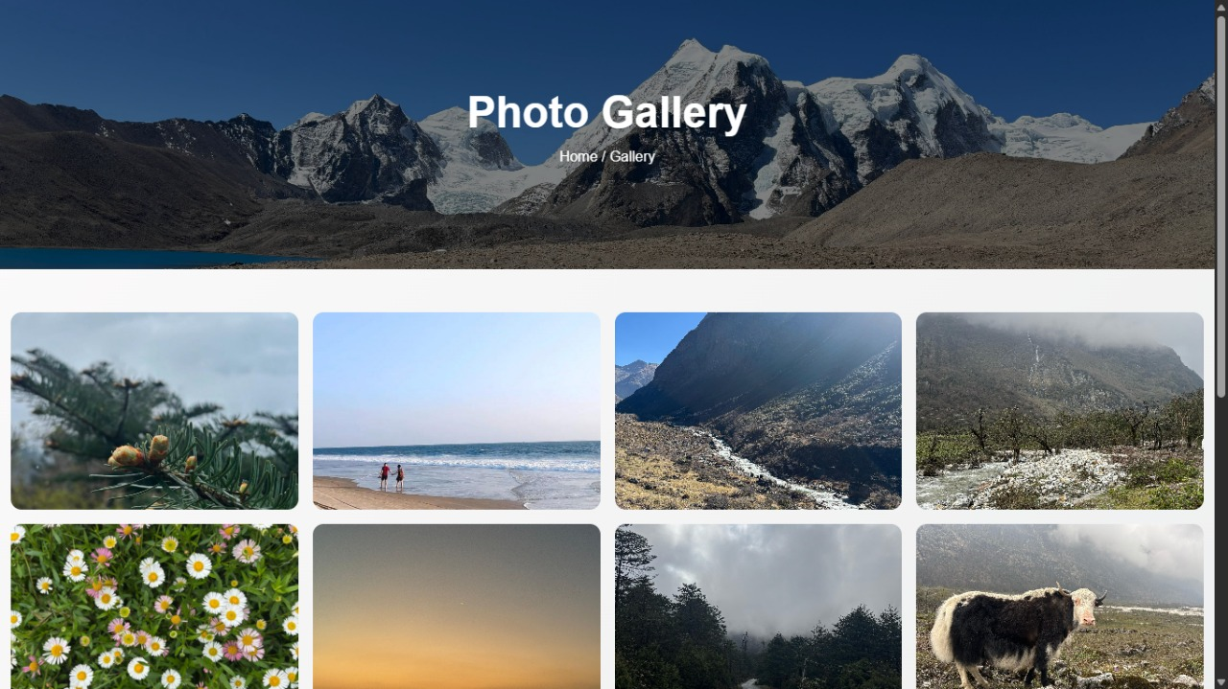

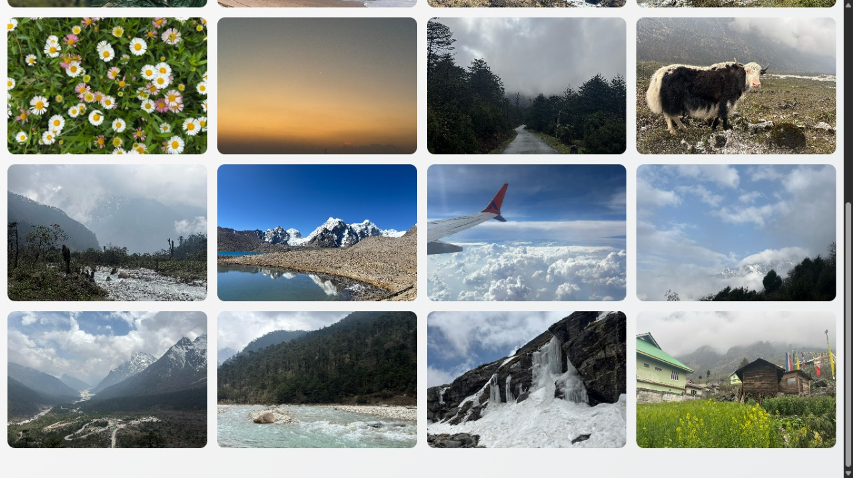

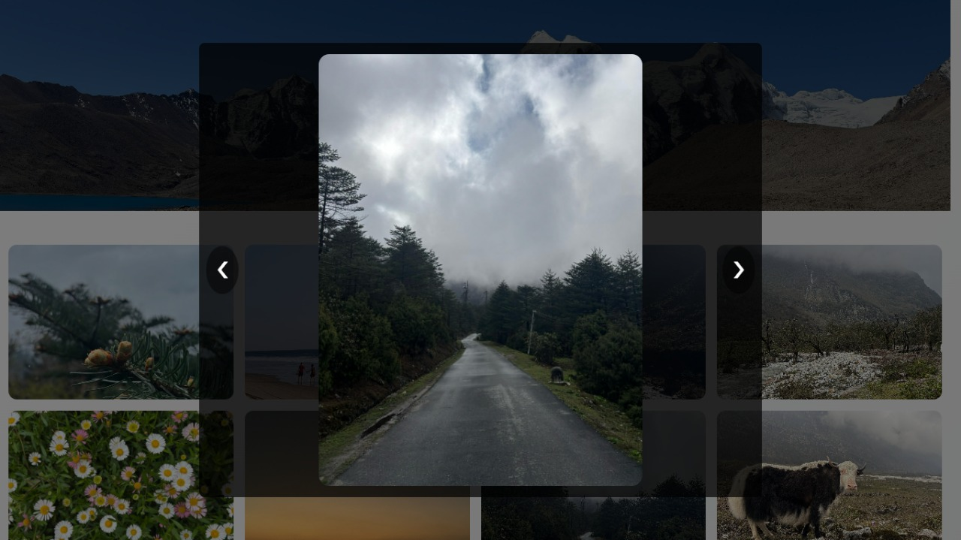

• Conclusion :

The Photo Gallery project successfully demonstrates how front-end technologies like **HTML, CSS, JavaScript, jQuery, and Bootstrap** can be combined to create a responsive and interactive application. It delivers a visually appealing layout, smooth animations, and user-friendly navigation features, making it suitable for both personal and professional use. By addressing challenges such as responsiveness, consistent design, and intuitive interaction, the project highlights practical problem-solving in web development. While the current version meets its objectives as a mini-project, it also lays a strong foundation for future enhancements such as dynamic content integration, filters, and mobile-specific interactions, making it adaptable to real-world applications.

• References :

L&T LMS : https://learn.lntedutech.com/Landing/MyCourse